

**RAMNIRANJAN JHUNJHUNWALA COLLEGE**

**GHATKOPAR (W), MUMBAI - 400 086**

**DEPARTMENT OF INFORMATION TECHNOLOGY**

**2020 - 2021**

**M.Sc.( I.T.) SEM I**

**Image And Vision Processing**

**Name:Priya Siddhnath Yadav**

**Roll No.: 20**

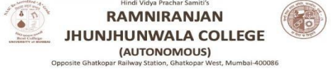

**CERTIFICATE**

This is to certify that Mr/Miss/Mrs. **Priya Siddhnath Yadav** with **Seat No: 20** has successfully completed the necessary course of experiments in the subject of **Image & Vision Processing** during the academic year 2020 – 2021 complying with the requirements of RAMNIRANJAN JHUNJHUNWALA COLLEGE OF ARTS, SCIENCE AND COMMERCE, for the course of M.Sc. (IT) semester -I.

_________________________________ 25 th Feb 2021

Internal Examiner Date

_________________________________ __________________

Head Of Department College Seal External Examiner

**INDEX**

|  |  |  |
| --- | --- | --- |
| **NO.** | PRACTICAL | PAGE |
| 1. | Implement Basic Intensity transformation functions   1. A) Image Inverse 2. B) Log Transformation 3. C) Power-law Transformation |  |
| 2. | Piecewise Transformation   1. A) Contrast Stretching 2. B) Thresholding 3. C) Bit-Plane Slicing |  |
| 3. | Implement Histogram Equalization |  |
| 4. | Image filtering in Spatial Domain   1. A) Low-pass Filter/Smoothing Filters   (Average, Weighted Average, Median and Gaussian)   1. B) High-pass Filter / Sharpening Filter   (Laplacian Filter, Sobel, Robert and Prewitt Filter to detect edge) |  |
| 5. | Analyze image in Frequency Domain   1. A) Low Pass/Smoothing filter 2. B) High Pass/Sharpening filter |  |
| 6. | Color Image Processing   1. A) Pseudocoloring 2. B) Separating the RGB Channels 3. C) Color Slicing |  |
| 7. | Image Compression Techniques and watermarking  A) Implement Huffman Coding  B) Add a watermark to the image |  |
| 8. | Basic Morphological Transformations  A) Boundary Extraction  B) Thinning and Thickening  C) Hole filling and Skeletons |  |

**Practical 1: Implement Basic Intensity transformation functions**

**Practical 1 (A) Image Inverse:**

The negative or inverse of an image with intensity levels in the range [0, L-1] is obtained by using the negative transformation, which is given by the expression,

S = L – 1 – r

Where L – 1 (Maximum pixel value)

r (Pixel of an image)

**Code:**

x = imread('rose.jpg');

x = rgb2gray(x);

x = im2double(x);

[row col] = size(x);

for i = 1:row

for j = 1:col

N(i,j)=1-x(i,j);

endfor

endfor

figure

imshow(x);

title('Original Image');

figure

imshow(N);

title('Negative Transformation Filtered Image');

Output: Figure 1

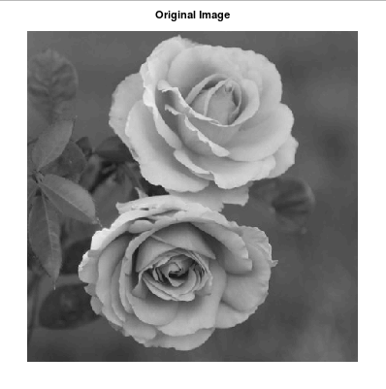

Figure 2:

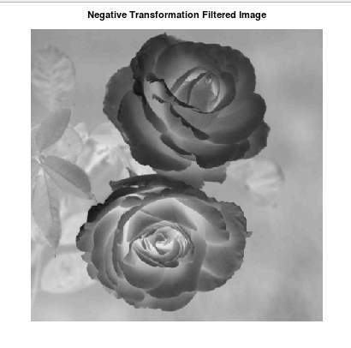

**Practical 1(b) - Log Transformation:**

The log transformation maps a narrow range of low intensity values in the input into a wider range of output levels. We use the transformation if this type to extend the values of dark pixel in an image while compress the higher-level values.

The general form of the log transformation is:

s = c log (r + 1)

Where c is a constant, and r ≥ 0.

**Code**

x = imread('rose.jpg');

x = rgb2gray(x);

x = im2double(x);

[row col] = size(x);

c = 2;

for i = 1:row

for j = 1:col

N(i,j) = c*log(1+x(i,j));

endfor

endfor

figure

imshow(x);

title('Original Image');

figure

imshow(N);

title('Log Transformation Filtered Image');

Output: Figure 1

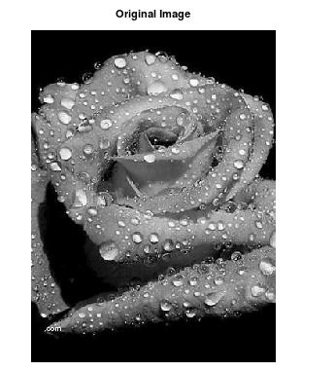

Figure 2:

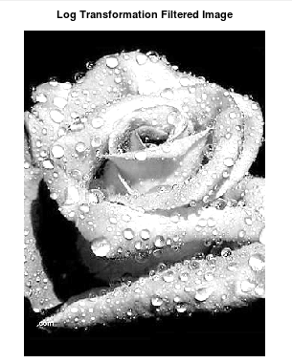

**Practical No. 1 ( c ) Power-Law Transformation:**

Power-law curves with fractional values of γ map a narrow range of dark input values into a wider range of output values, with the opposite being true for higher values of input levels.

The nth power and nth root curves shown in below figure can be given by the expression as s = c r γ, This transformation function is also called as gamma correction. For various values of γ different levels of enhancements can be obtained. It is used to correct power law response phenomena. The different display monitors display images at different intensities and clarity. That means, every monitor has built-in gamma correction in it with certain gamma ranges and so a good monitor automatically corrects all the images displayed on it for the best contrast to give user the best experience. The gamma variation changes ratio of red green & blue along with intensity in color images. The difference between the log-transformation function and the power-law functions is that using the power-law function a family of possible transformation curves can be obtained just by varying the λ. This process is also called a gamma correction.

The Power Low Transformations can be given by the expression:

s = c * r ^ γ where, s is the output pixels value r is the input pixel value c and γ are the real numbers

**Code**

x = imread('rose.jpg');

x = rgb2gray(x);

x = im2double(x);

[row col] = size(x);

gamma = 2;

c = 1;

for i = 1:row

for j = 1:col

N(i,j) = c*(x(i,j)^gamma);

endfor

endfor

figure, imshow(x);

title('Original Image');

figure, imshow(N);

title('Gamma Transformation Filtered Image');

Output:Figure 1

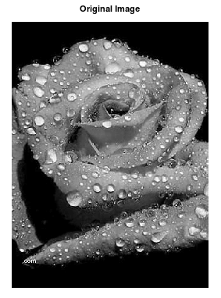

Figure 2:

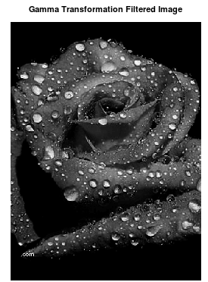

**Practical 2 - Piecewise Transformation**

**Practical 2(a)- Contrast Stretching**

1. Using imadjust function

pkg load image;

a=imread('dog.jpg');

agray=rgb2gray(a);

ad=im2double(agray);

subplot(2,2,1); imshow(ad); title("before");

subplot(2,2,2); imhist(ad); title("before hist");

imad=imadjust(ad,[0.11 0.88],[0.1 0.9]);

subplot(2,2,3); imshow(imad); title("After");

subplot(2,2,4); imhist(imad); title("After hist");

Output:

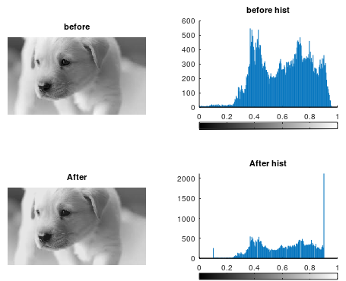

**Practical 2(a)- Contrast Stretching using user Inputs**

**Using inputs from user r1,r2,s1,s2**

pkg load image;

clear all;

r = imread("dog.jpg");

r = im2double(r);

[m n] = size(r);

r1=input("Enter R1: ");

r2=input("Enter R2: ");

s1=input("Enter S1: ");

s2=input("Enter S2: ");

a = s1/r1;

b = (s2-s1)/(r2-r1);

c = (255-s2)/(255-r2);

for i=1:m

for j=1:n

if r(i,j) < r1

s(i,j) = a*r(i,j);

elseif r(i,j) < r2

s(i,j) = b*(r(i,j)-r1)+s1;

else

s(i,j) = c*(r(i,j)-r2)+s2;

endif

endfor

endfor

figure(3);

subplot(2,2,1)

imshow(r);

title("Original Image");

subplot(2,2,2)

imhist(r);

title('Histogtram Of Original Image');

subplot(2,2,3)

imshow(s);

title("Contrast Streched Image");

subplot(2,2,4)

imhist(s);

title('Histogtram Of Contrast Streched Image');

Output:

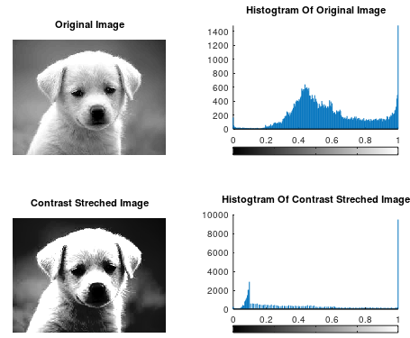

1. Thresholding

pkg load image;

clear all;

r=imread("dog2.jpg");

imhist(r);

thr=150;

[m n]=size(r);

s=zeros(m,n);

for i=1:m

for j=1:n

if(r(i,j))>thr

s(i,j)=1;

else

s(i,j)=0;

endif

endfor

endfor

subplot(2,2,1); imshow(r); title("original");

subplot(2,2,2); imhist(r); title("original histogram");

subplot(2,2,3); imshow(s); title("thresholded image");

subplot(2,2,4); imhist(s); title("threshold histogram");

Output:

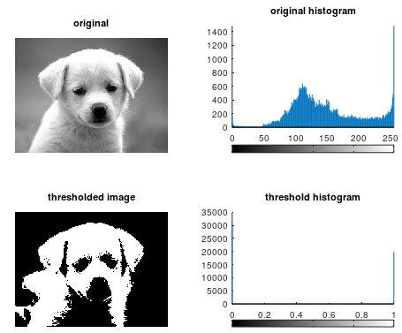

**Practical -2 ( C ) -Image reconstruction using n bit planes**

A=imread('dog.jpg');

g=rgb2gray(A);

B=zeros(size(g));

g1 = bitget(g,1);

g2 = bitget(g,2);

g3 = bitget(g,3);

g4 = bitget(g,4);

g5 = bitget(g,5);

g6 = bitget(g,6);

g7 = bitget(g,7);

g8 = bitget(g,8);

figure,

subplot(2,2,1)

imshow(logical(g1));

title('Bit 1');

subplot(2,2,2)

imshow(logical(g2));

title("Bit 2");

subplot(2,2,3)

imshow(logical(g3));

title('Bit 3');

subplot(2,2,4)

imshow(logical(g4));

title('Bit 4');

figure,

subplot(2,2,1)

imshow(logical(g5));

title('Bit 5');

subplot(2,2,2)

imshow(logical(g6));

title("Bit 6");

subplot(2,2,3)

imshow(logical(g7));

title('Bit 7');

subplot(2,2,4)

imshow(logical(g8));

title('Bit 8');

B=bitset(B,5,g5);

B=bitset(B,6,g6);

B=bitset(B,7,g7);

B=bitset(B,8,g8);

B=uint8(B);

figure,

subplot(1,2,1),imshow(B); title("5,6,7,8")

subplot(1,2,2),imshow(g); title("original image");

Output:

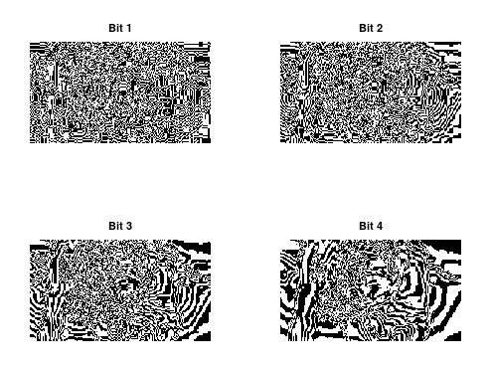

Figure 2:

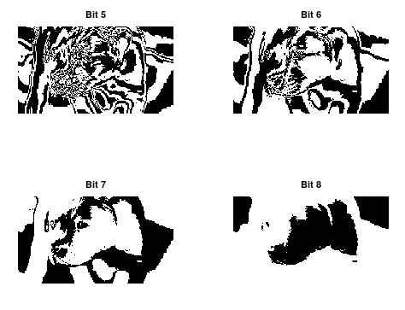

Figure 3:

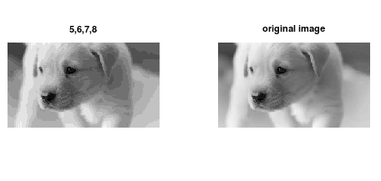

**Practical-3**

**Histogram equalization without using histeq() function**.

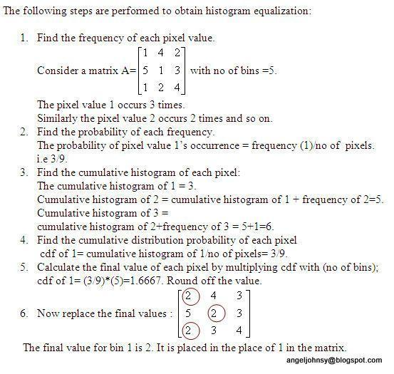

**Histogram equalization without using histeq() function.**

clear all;

close all;

pkg load image;

a=imread('scene.jpg');

#a=rgb2gray(a);

#a=a(1:10,1:10)

r=size(a,1);

c=size(a,2);

ah=uint8(zeros(r,c));

n=r*c;

f=zeros(256,1);

pdf=zeros(256,1);

cdf=zeros(256,1);

cumm=zeros(256,1);

out=zeros(256,1);

for i=1:r

for j=1:c

values=a(i,j);

f(values+1)=f(values+1)+1;

pdf(values+1)=f(values+1)/n;

endfor

endfor

sum=0; L=255; size(pdf);

for i=1:size(pdf)

sum=sum+f(i);

cum(i)=sum;

cdf(i)=cum(i)/n;

out(i)=round(cdf(i)*L);

endfor

for i=1:r

for j=1:c

ah(i,j)=out(a(i,j)+1);

endfor

endfor

figure,

subplot(2,2,1), imshow(a); title('original image');

subplot(2,2,2), imhist(a); title('original hist');

#he=histeq(a);

subplot(2,2,3), imshow(ah); title('after processing image');

subplot(2,2,4), imhist(ah); title('after processing hist');

#imhist(he);

Output:

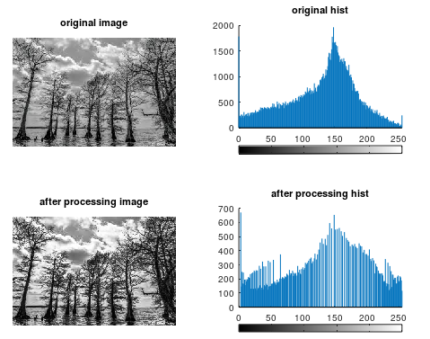

**Practical -4 Image filtering in Spatial Domain**

**Practical 4 (A) Low Pass- Average filter using inbuilt functions)**

pkg load image;

a=imread('g1.jpg');

a=rgb2gray(a);

#imwrite(a,'g1.jpg');

a=im2double(a);

r=imnoise(a,'salt & pepper' );

f=ones(3,3)/9;

af=filter2(f,r);

figure

#imshow(a); title('original');

subplot(1,2,1);imshow(af); title('After applying average filter');

subplot(1,2,2)

imshow(r); title('noised image');

Output:

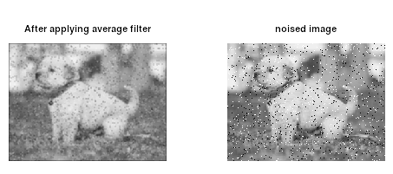

**b) Low pass- Average filter without using inbuilt functions**

close all;

pkg load image;

im=imread('dog.jpg'); % To read image

#f=rgb2gray(im); % To convert RGB to Gray image

Nim=imnoise(im,'salt & pepper'); % Adding salt & pepper noise to image

w=(1/16)*[1 2 1;2 4 2;1 2 1]; % Defining the box filter mask

% get array sizes

[ma, na] = size(Nim)

[mb, nb] = size(w)

% To do convolution

c = zeros( ma+mb-1, na+nb-1 );

size_c=size(c)

for i = 1:mb

for j = 1:nb

r1 = i

r2 = r1 + ma - 1

c1 = j

c2 = c1 + na - 1

c(r1:r2,c1:c2) = c(r1:r2,c1:c2) + w(i,j) * (Nim);

end

end

% extract region of size(a) from c

r1 = floor(mb/2) + 1;

r2 = r1 + ma - 1;

c1 = floor(nb/2) + 1;

c2 = c1 + na - 1;

c = c(r1:r2, c1:c2);

figure

subplot(1,2,1)

imshow(Nim);

title('Noisy Image(Salt & Pepper Noise)');

subplot(1,2,2)

imshow(uint8(c));

title('Denoised Image using Weighted Average Operation of Box Filter');

Output:

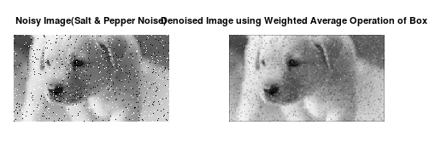

**c) Low Pass filter-(Median filter)**

Median spatial domain filtering

close all;

pkg load image;

# Read the image

a=imread('rose.jpg');

f=rgb2gray(a);

img_noisy1=imnoise(f,'salt & pepper' );

# Obtain the number of rows and columns of the image

[m, n] = size(img_noisy1)

# Traverse the image. For every 3X3 area,

# find the median of the pixels and

# replace the center pixel by the median

img_new1 = zeros(m, n);

for i=2: m-1

for j =2: n-1

temp = [img_noisy1(i-1, j-1),

img_noisy1(i-1, j),

img_noisy1(i-1, j + 1),

img_noisy1(i, j-1),

img_noisy1(i, j),

img_noisy1(i, j + 1),

img_noisy1(i + 1, j-1),

img_noisy1(i + 1, j),

img_noisy1(i + 1, j + 1)] ;

temp = sort(temp);

img_new1(i, j)= temp(4);

endfor

endfor

img_new1 = uint8(img_new1);

figure

subplot(1,2,1); imshow(img_new1); title('After Applying Median Filter');

subplot(1,2,2); imshow(img_noisy1);title('noisy image');

Output:

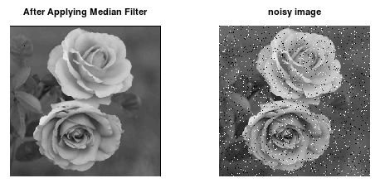

**d) Second order derivative - The Laplacian filter**

%Input Image

clear all;

A=imread('nature3.jpg');

size(A);

figure,

subplot(2,2,1);imshow(A); title('original Image');

%Preallocate the matrices with zeros

I1=A;

I=zeros(size(A));

I2=zeros(size(A));

%Filter Masks

F1=[0 2 0;2 -8 2; 0 2 0];

#F2=[1 1 1;1 -8 1; 1 1 1];

%Padarray with zeros

A=padarray(A,[1,1]);

A=double(A);

size(A);

%Implementation of the equation in Fig.D

for i=1:size(A,1)-2

for j=1:size(A,2)-2

I(i,j)=sum(sum(F1.*A(i:i+2,j:j+2)));

end

end

I=uint8(I);

subplot(2,2,3);imshow(I);title('Filtered Image');

%Sharpenend Image

B=I1-I;

subplot(2,2,4); imshow(B);title('Sharpened Image');

Output:

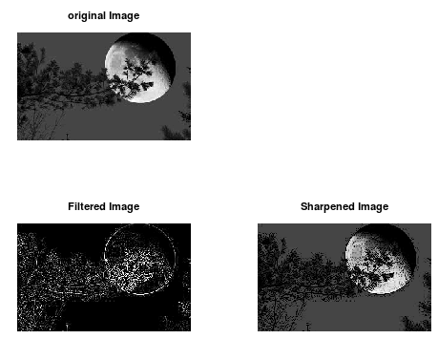

**e) First Order Derivative -Sobel Operator for edge detection without using edge function**

clear all;

A=imread('dog.jpg');

figure,

subplot(1,2,1); imshow(A); title('Original');

C=double(A);

size(C)

for i=1:size(C,1)-2

for j=1:size(C,2)-2

%Sobel mask for x-direction:

Gx=((C(i+2,j)+2*C(i+2,j+1)+C(i+2,j+2))-(C(i,j)+2*C(i,j+1)+C(i,j+2)));

%Sobel mask for y-direction:

Gy=((C(i,j+2)+2*C(i+1,j+2)+C(i+2,j+2))-(C(i,j)+2*C(i+1,j)+C(i+2,j)));

%The gradient of the image

# B(i,j)=abs(Gx)+abs(Gy);

A(i,j)=sqrt(Gx.^2+Gy.^2);

end

end

subplot(1,2,2); imshow(A); title('Sobel gradient');

Output:

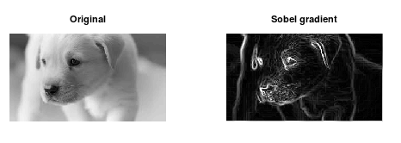

**f) First Order Derivative -** **Sobel Operator for edge detection using Edge function**

#load package of image

pkg load image;

#Take input image

img=imread("nature.jpg");

f=rgb2gray(img);

#function to find edge using sobel filter

sobel = edge(f,'Sobel');

figure 1,

subplot(1,2,1)

imshow(f);

title('Original Image');

subplot(1,2,2)

imshow(sobel);

title("Edge detection using sobel filter");

#function to find edge using sobel filter

robert = edge(f,'Roberts');

prewitt = edge(f,'Prewitt');

figure 2,

subplot(1,2,1)

imshow(robert);

title('Edge detection using robert filter');

subplot(1,2,2)

imshow(prewitt);

title("Edge detection using prewitt filter");

Output: Figure1

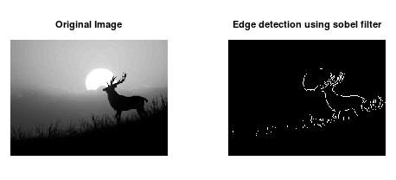

Figure2:

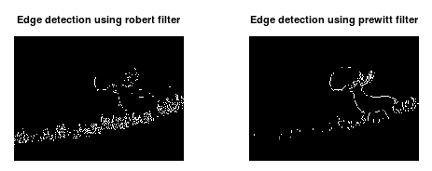

**Practical no. 6 Color Image Processing**

1. **Prac 6 - (A) Pseudocoloring**

pkg load image; close all; clear all;

%READ INPUT IMAGE

A = imread('coins.png');

%RESIZE IMAGE

A = imresize(A,[256 256]);

%PRE-ALLOCATE THE OUTPUT MATRIX

Output = ones([size(A,1) size(A,2)]);

%COLORMAPS

#maps={'jet(256)';'hsv(256)';'cool(256)';'spring(256)';'summer(256)';'parula(256)';'hot(256)'};

%COLORMAP 1

map = colormap(jet(256));

Red = map(:,1);

Green = map(:,2);

Blue = map(:,3);

R1 = Red(A);

G1 = Green(A);

B1 = Blue(A);

%COLORMAP 2

map = colormap(cool(256));

Red = map(:,1);

Green = map(:,2);

Blue = map(:,3);

%RETRIEVE POSITION OF UPPER TRIANGLE

[x,y]=find(triu(Output)==1);

Output(:,:,1) = Red(A);

Output(:,:,2) = Green(A);

Output(:,:,3) = Blue(A);

for i=1:numel(x)

Output(x(i),y(i),1)=R1(x(i),y(i));

Output(x(i),y(i),2)=G1(x(i),y(i));

Output(x(i),y(i),3)=B1(x(i),y(i));

end

Output = im2uint8(Output);

%FINAL IMAGE

imshow(Output);

Output:

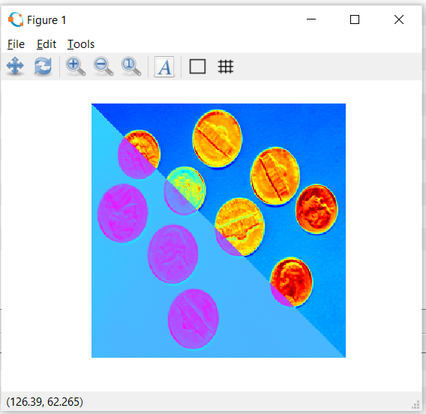

1. **Prac 6 - (B) Separating the RGB Channels**
2. rgbImage = imread('dog.jpg');
3. a = zeros(size(rgbImage, 1), size(rgbImage, 2));
4. red = rgbImage(:,:,1);
5. green = rgbImage(:,:,2);
6. blue = rgbImage(:,:,3);
7. figure 1;
8. subplot(2,2,1); imshow(rgbImage);title('Original Image');
9. subplot(2,2,2);imshow(cat(3, red, a, a));title('Red channel');
10. subplot(2,2,3);imshow(cat(3, a,green, a));title('Green channel');
11. subplot(2,2,4);imshow(cat(3, a, a,blue));title('Blue Channel');

**Output:**

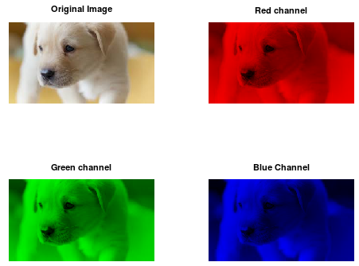

1. **Prac 6 - (C) Intensity slicing**

clear all;

#im=input('Enter the file name);

input_image=imread('dog.jpg');

k=rgb2gray(input_image);

[x y z]=size(k);

% z should be one for the input image

k=double(k);

for i=1:x

for j=1:y

if k(i,j)>=0 && k(i,j)<50

m(i,j,1)=k(i,j,1)+25;

m(i,j,2)=k(i,j)+50;

m(i,j,3)=k(i,j)+60;

end

if k(i,j)>=50 && k(i,j)<100

m(i,j,1)=k(i,j)+55;

m(i,j,2)=k(i,j)+68;

m(i,j,3)=k(i,j)+70;

end

if k(i,j)>=100 && k(i,j)<150

m(i,j,1)=k(i,j)+52;

m(i,j,2)=k(i,j)+30;

m(i,j,3)=k(i,j)+15;

end

if k(i,j)>=150 && k(i,j)<200

m(i,j,1)=k(i,j)+50;

m(i,j,2)=k(i,j)+40;

m(i,j,3)=k(i,j)+25;

end

if k(i,j)>=200 && k(i,j)<=256

m(i,j,1)=k(i,j)+120;

m(i,j,2)=k(i,j)+60;

m(i,j,3)=k(i,j)+45;

end

end

end

figure,

imshow(uint8(k),[]);

title('Original Image');

figure,

imshow(uint8(m),[]);

title("Pseudo filtred image");

**Output:**

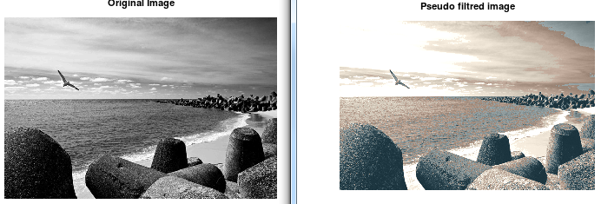

**Pseudo Image**

**Gray To Color Transformation**

pkg load image;

clear all;

img = imread('nature.png'); % Read image

img = rgb2gray(img);

figure, imshow(img);title("original Image");

red = 0.66*img;

green=0.25*img;

blue = img;

pseudo_img = cat(3, red, green, blue);

figure, imshow(pseudo_img), title('Pseudo Image');

**Output:**

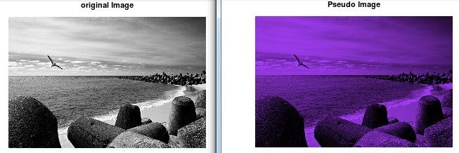

**Practical -7 Image Compression Techniques and watermarking**

**Prac 7 (A) - Implement Huffman Coding:**

Code:

pkg load communications

sig = repmat([3 3 1 3 3 3 3 3 2 3],1,50);

symbols = [1 2 3];

p = [0.1 0.1 0.8];

dict = huffmandict(symbols,p);

hcode = huffmanenco(sig,dict);

dhsig = huffmandeco(hcode,dict);

isequal(sig,dhsig)

binarySig = de2bi(sig);

seqLen = numel(binarySig)

binaryhcode = de2bi(hcode);

encodedLen = numel(binaryhcode)

Prac 7 - B Watermarking

pkg load image;

clear all;

close all;

#Input Image where we want to apply watermark

f=imread('dog.jpg');

#For watermarking, size of inputimage and watermarking image should be same

#there for we changed the size of image using imresize and dispalyed

fr=imresize(f,[560 560]);

figure;imshow(fr);

title('Original Image with resized');

#Watermarking Image

w=imread('nature.jpg');

#Again Resized the Watermarking Image

wr=imresize(w,[560 560]);

figure;imshow(wr);

title('watermark');

#Applied watermarking

alpha=0.7;

fw=(1-alpha)*fr + alpha.*wr;

#Display the watermarked Image

figure;imshow(fw);

title('Watermaked Image');

**Output:**

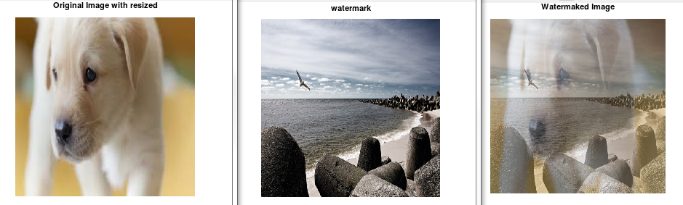

**Prac 8 - (A) - Boundary Extraction**

**Code:**

#Read input image

pkg load image;

org_im = imread('coin.jpg');

figure 1, imshow(org_im); title('Original Image');

#Convert RGB image to Binary Image and Displayed as Input Image

A=im2bw(org_im);

se=strel('disk',1,0);

F=imerode(A,se);

figure 2, imshow(F);title("eroded");

figure 3, imshow(A-F); title("boundary");

Output:

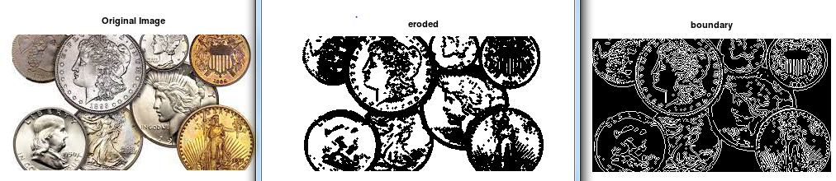

**Prac -8 (B) -Thinning and Thickening**

pkg load image;

myorigimg = imread('word.png');

thinf = bwmorph(myorigimg,'thin');

figure 2

subplot(2,2,1);

imshow(thinf);title('Thinning of the Image');

thickf = bwmorph(myorigimg,'thicken');

subplot(2,2,2);

imshow(thickf);title('Thickening of the Image');

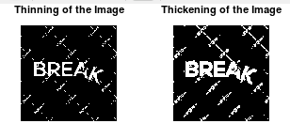

**Prac 8 - C) Hole filling and Skeleton**

pkg load image;

clear all; close all;

#Read input image

org_im = imread('coins.png');

#Convert RGB image to Binary Image and Displayed as Input Image

A=im2bw(org_im);

figure 1, imshow(A); title("binary image");

hole_filled=bwfill(A,'holes');

figure 2, imshow(hole_filled); title("hole filled image");

skelf100 = bwmorph(hole_filled,'skel',Inf);

figure 3;

imshow(skelf100);title('Skeletonization');

Output:

